**Installing Ansible Tower**

**Introduction:**

**Ansible Tower** is a web-based solution that makes Ansible even more easy to use for IT teams of all kinds. It’s designed to be the hub for all of your automation tasks.

* The Tower, helps you to manage your entire infrastructure by easily pull inventory from **public cloud providers** such as **Amazon Web Services**, **Microsoft Azure**. Further, launching Playbooks with just a single click or even by scheduling jobs.
* Ansible Tower is free for usage for up to 10 nodes.

1. Let us install the EPEL Release repository

# dnf install -y epel-release

Output:

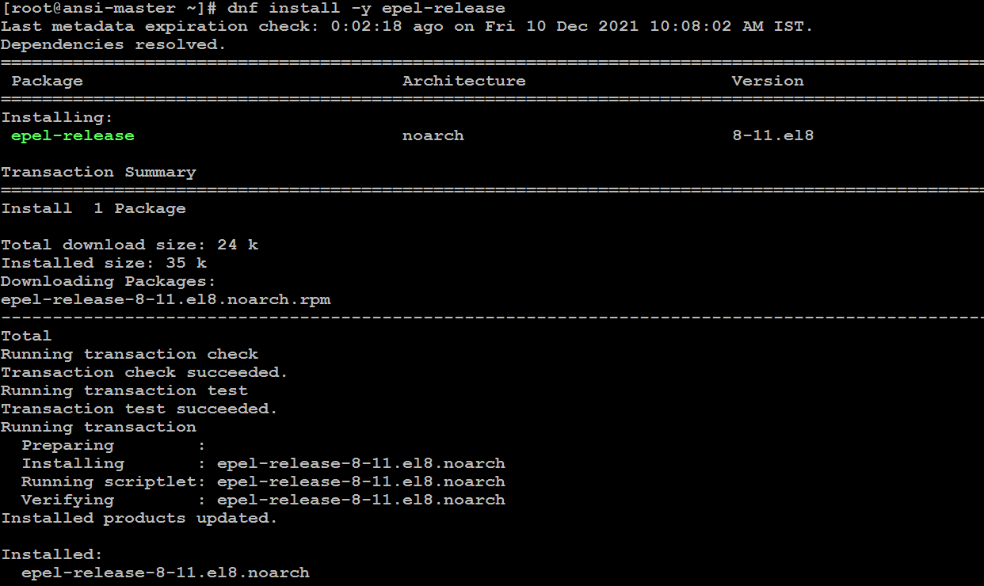

* 1. Let’s download the latest package for ansible tower

# mkdir -p ansible-tower

# cd ansible-tower

# curl -O <https://releases.ansible.com\>

/ansible-tower/setup/ansible-tower-setup-latest.tar.gz

Output:



* 1. Lets Untar and unzip the package file:

# tar xvfz ansible-tower-setup-latest.tar.gz

Output:

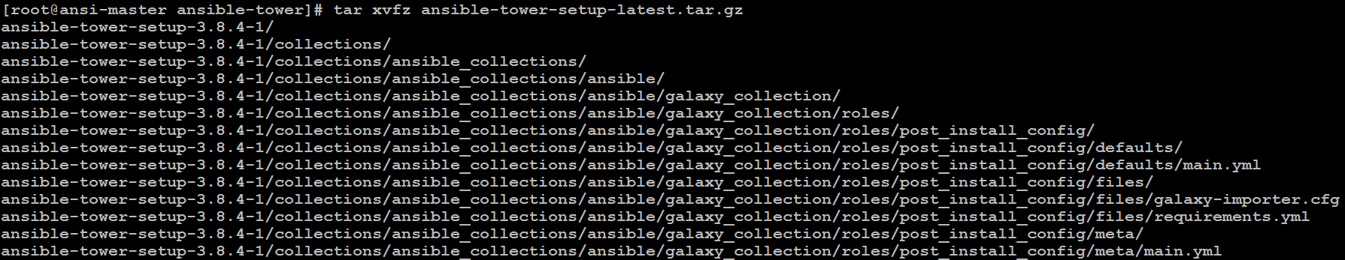

* 1. Change the directories into the Ansible tower setup package as below

# cd ansible-tower-setup-*/

* 1. Let’s Open the i**nventory** file and fill out the below variables **admin_password**, **pg_password** and **rabbitmq_password**:

Note: Add Password as **linux**

# ls

# vim inventory

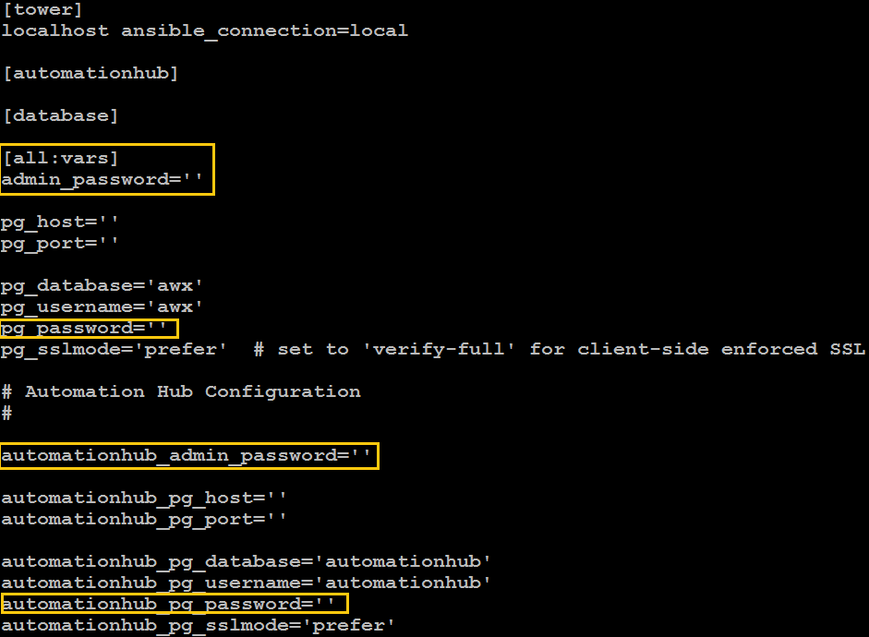

* 1. let’s Run the Ansible Tower setup script as below command to start the installation:

# ./setup.sh

Output:

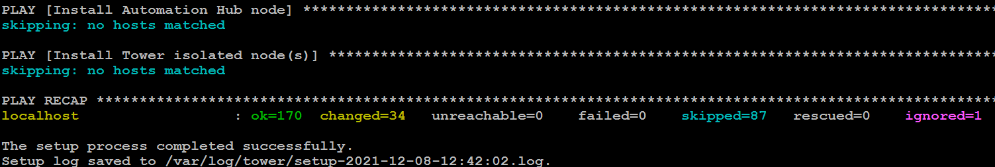

Note: Tha ansible setup process may take around **5 to 10** min

* 1. Lets verify the status of ansible-tower-service

# supervisorctl status

Output:

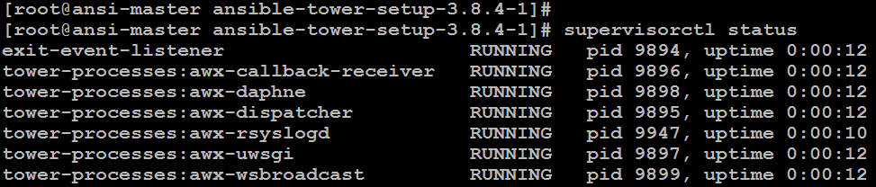

* 1. 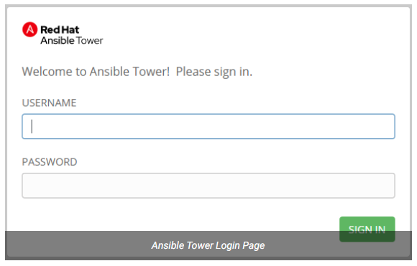Now Let’s open your **browser**, access the **Ansible Tower** web interface with your **server’s IP**, the username is **admin** and the **password** that you configured in the inventory file.

After Login

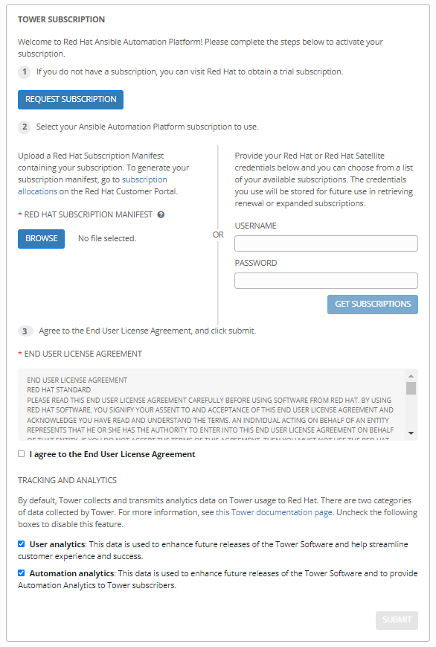

* 1. After Tower subscription form you will directed to Dashboard

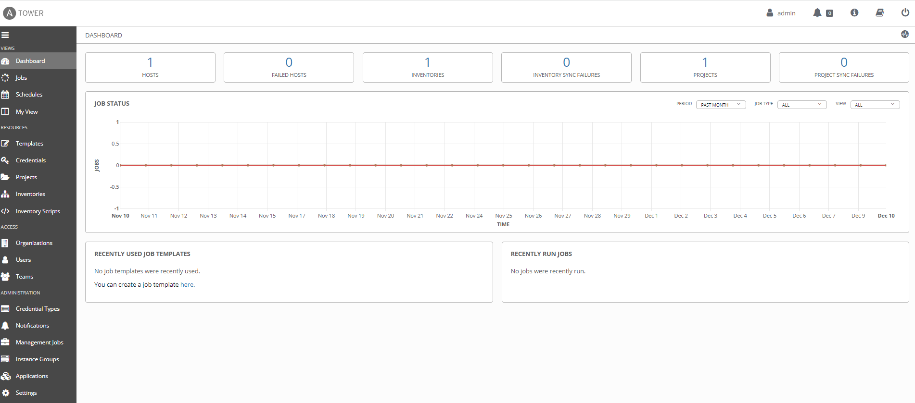

1. Let us Add A New Inventory, Create A Host And Credential In Ansible Tower

– To create a new inventory or Smart Inventory follow the below steps:

01- Click the Inventories icon from the left navigation bar.

02- Click the add button +, and select the type of inventory to create.

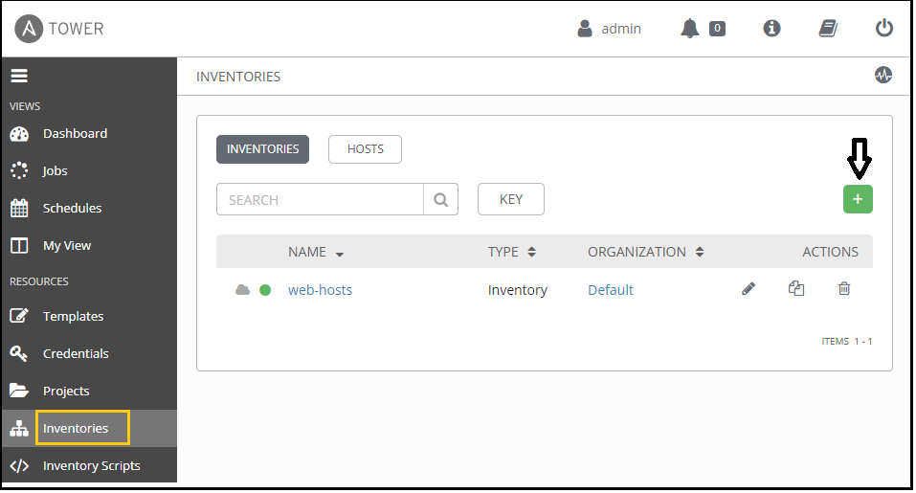

03- Enter the required details like the name, description and organization as below:

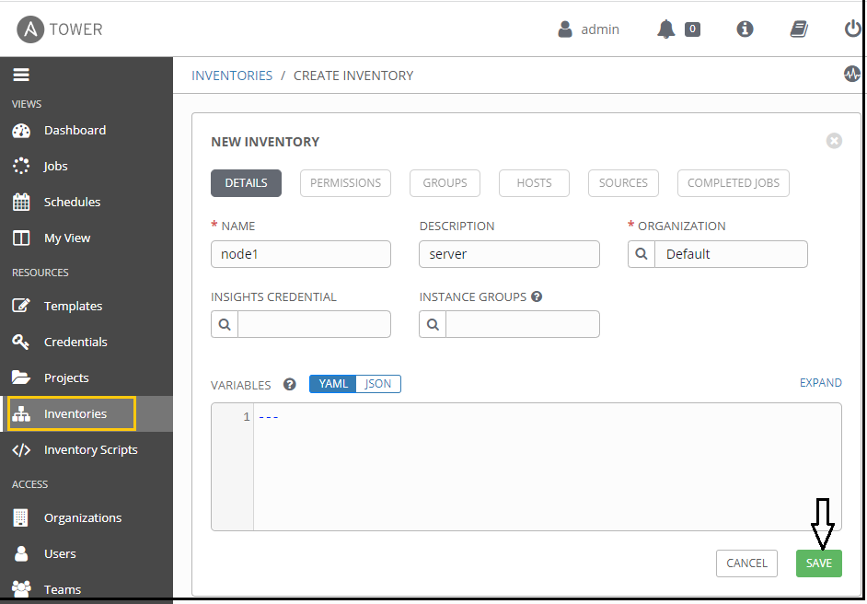

04- Click Save when done.

1. **Create a Host**

After creating a new inventory, you can proceed with configuring a new host. To create a host, follow the below steps:

01- Go the Inventories tab and choose the inventory to which you want to add hosts.

02- Select the Hosts tab and click on create a new host button + .

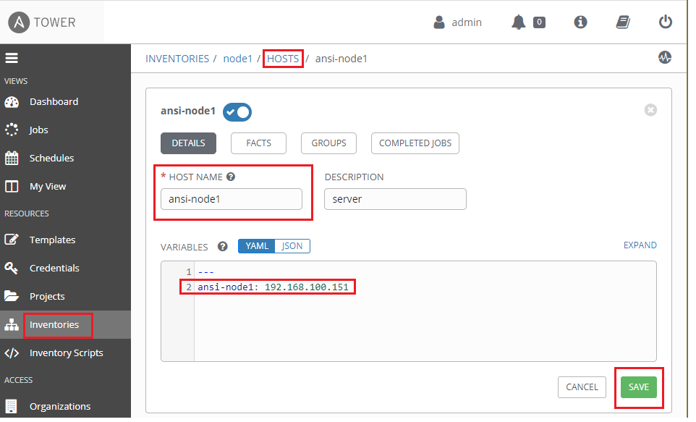

04- Click Save when done.

1. **Let’s Create a Credential**

Credentials authenticate to launch Ansible playbooks, which can include passwords and SSH keys, against inventory hosts.

1. From the left navigation bar, click the Credentials icon:
2. Specify the type of credential you want to create. The credential type could be **Amazon Web Services**, **Microsoft Azure Resource Manager**, **Machine**, … In this example we will select **machine** Credential type:

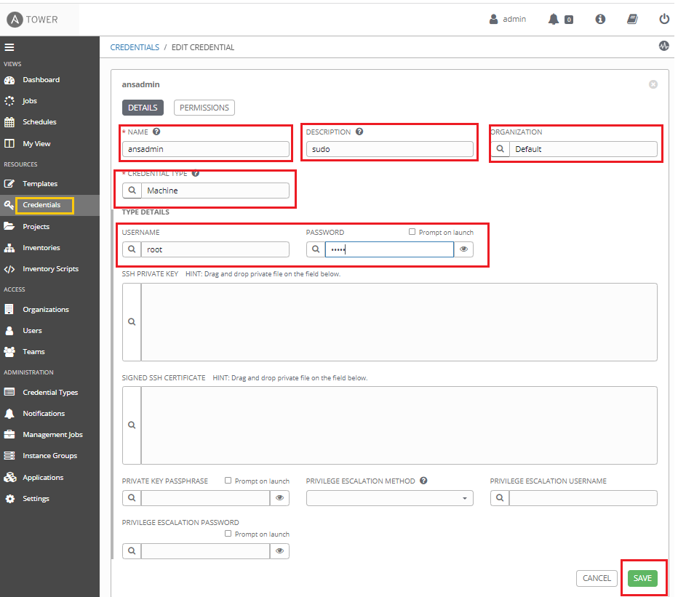

1. Let’s Create a Credential for SCM (source content manager)

Step1: Creating a personal access token to create click the below link

<https://docs.github.com/en/authentication/keeping-your-account-and-data-secure/creating-a-personal-access-token>

Let us add git hub credentials to integrate git

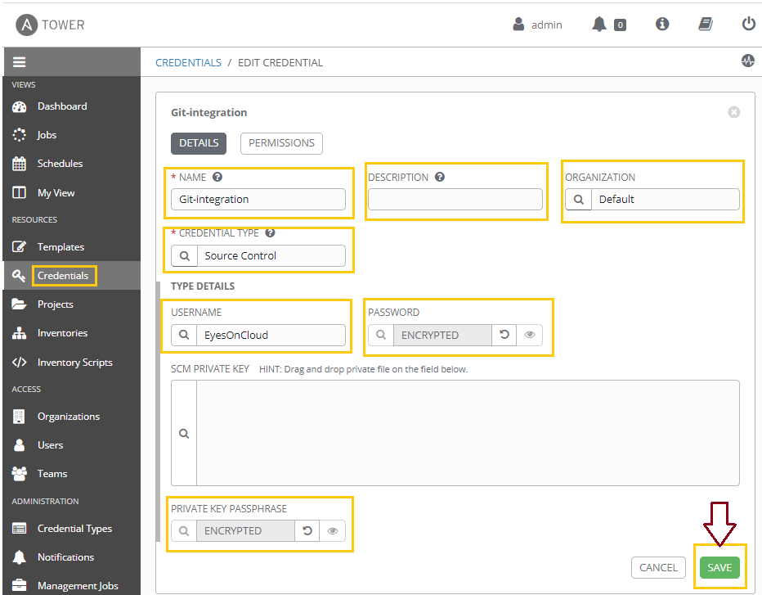

1. Creating a GitHub/GitLab SCM Project

01- Click the projects icon from the left navigation bar.

02- Click the add button + to create a new project.

03- Fill in all the necessary details such as Name, Description and Organization of Project. After that, select Git from the SCM type.

1. Now, we need to fill all resource details sucha as SCM Url, SCM Branch/Tag/Commit (by default is master) and choose SCM Credential in case that your repository is private.

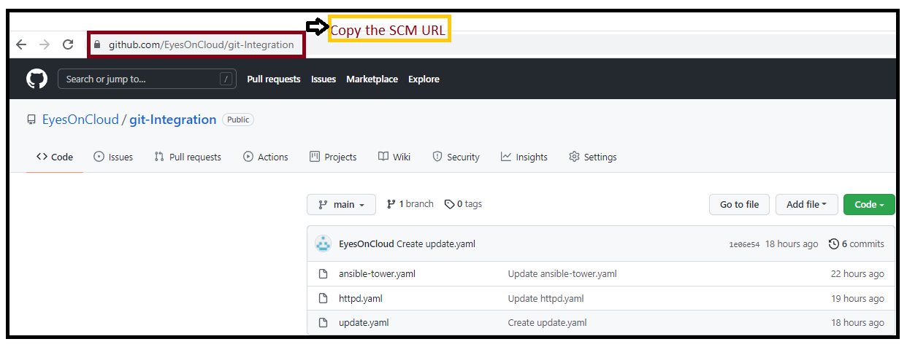

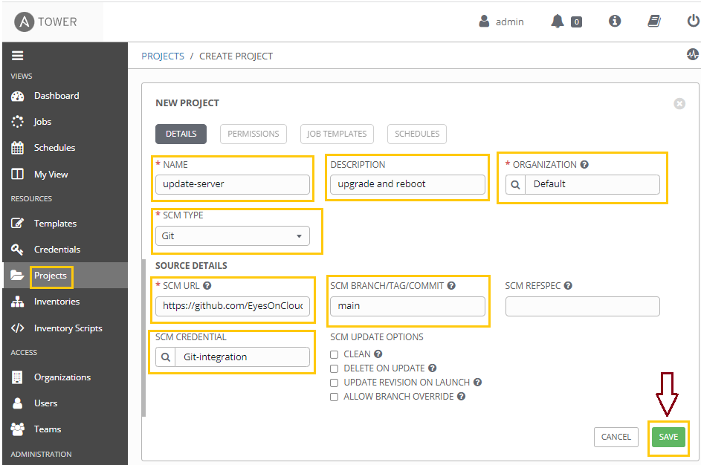

1. How To Create A New Job Template In Ansible Tower

– To create a new job template, follow the below steps:

01- Click the templates icon from the left navigation bar.

02- Click the + button then select Job Template from the menu list.

03- Enter the appropriate details into the following fields:

* Name: Enter a name for the job.
* Description: Enter an arbitrary description as appropriate (optional).
* Job Type: Could be Run or Check
* Inventory: Choose the inventory to be used with this job template from the inventories list.
* Project: Choose the project to be used with this job template from the projects list.
* Playbook: Choose the playbook to be launched with this job template from the available playbooks. This menu is automatically populated with the names of the playbooks found in the project base path for the selected project.
* Credential: Click the search button to open a separate window. Choose the credential from the available options to be used with this job template.

1. 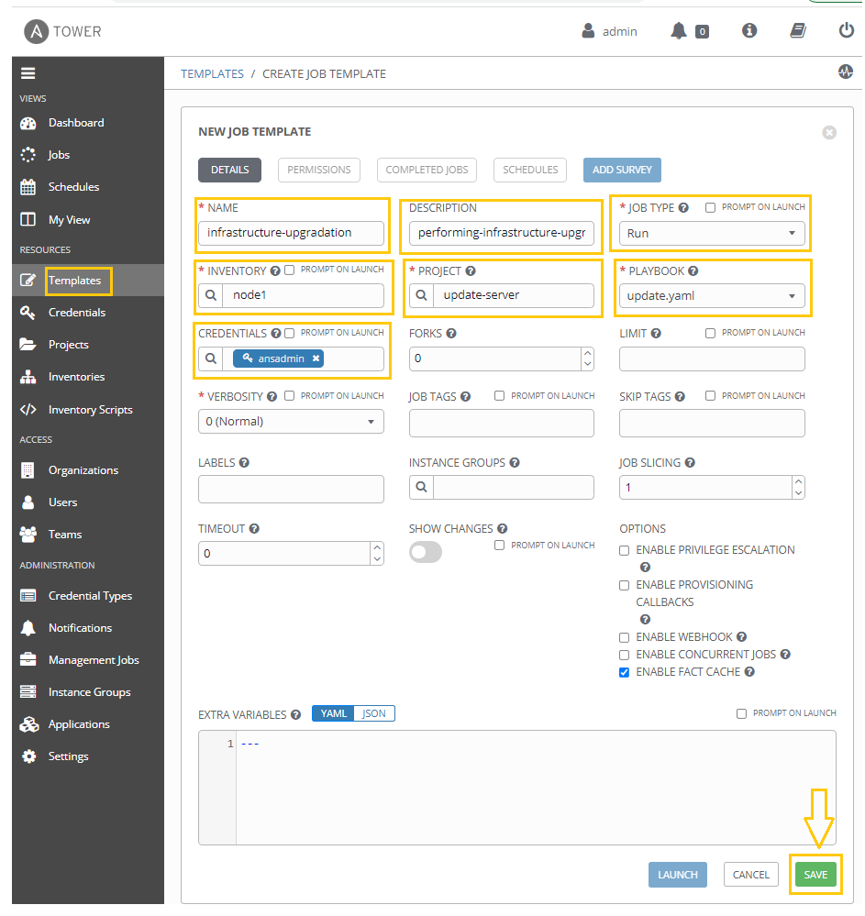

**04- Now that you’ve sucessfully created your Job Template, you are ready to launch it, click the rocketship icon:**



